UCD Data Certificate
Bertrand Meunier
Project Report
GitHub URL
https://github.com/Demainestloin/UCDPA_BertrandMeunier
Abstract
Using an open source database from French Transmission System Operator (TSO) 'ENEDIS', the project aims at illustrating the variability of electricity consumption in France, relative to the season and temperature.
The project imports data covering 2017 to 2022, and after some analytical and data transformation steps, illustrates the relation between several variables using matplotlib and seaborn.

Introduction
Electricity is an important source of heating in France, a temperate country with 4 distinct seasons. Mapping the level of electricity consumption against time and average temperature is expected to provide clear results, thus offering an interesting use-case for clear data visualisation output.
The French State and other state bodies have a developped open data culture and offer for free use a wide range of open data sources. The source data is easily available on open data website and offers many data manipulation opportunities.
These elements make it suitable as a case-study for this Data certificate project.

Dataset
The source data for this project has been taken from the following link :
https://erdf.opendatasoft.com/explore/dataset/bilan-electrique-jour/information/
Enedis (formerly ERDF) is the French monopolistic electricity TSO, like EirGrid in Ireland, so the data here is reliable for the subject.
The datase used here is a dataframe offering a wide range of open data on the electricity use and production in France on a daily basis, including among other total consumption and mean temperature for the day. Not every column will be used for the project.

Implementation Process
- Import process
A csv was downloaded and includes the whole data from March 2017 to March 2022. A copy is available in my Github repository ('electricity_database_full.csv').
The file is imported into the Python interface directly from Github as a panda dataframe with the pd.read_csv function, and several columns that will be used in the project are translated from French to English.
Pandas, Seaborn and Matplotlib are also imported at this step, for later use.
A run of the info() function is made for data discovery of the database :
- 1826 rows and 25 columns
- 9 rows with missing values, concentrated in 1 column
- various formats for the columns : 23 floats, 1 integer, 1 object

- Index creation and sorting
The first column of the dataframe ("Date") is turned into a datetime and made the index. The table is then sorted by chronological order.

- Data cleaning
This step aims at cleaning the data (filling the 9 NaN in the 'pseudo radiation' column with '0'), and creating new 'year' and 'day' colums from the "date" column. The "month" column is already present in the original database. These operations will allow for grouping in the next step.
A simplified dataframe keeping only the necessary columns and filtered on year 2019 is then created.

- Grouping and merge (2019)
The dataset contains information on a daily basis (temperature, electricity consumption, etc). This step calculates calculates the monthly mean of temperature and electricity use, as well as the total electricity consumption by month in 2019. This is done by the groupby() and .agg() functions.

These values are then merged back to the initial dataframe, using the merge function on a left join on 'Month'. As a reminder, only values for year 2019 are present in this dataframe.
The newly added columns are renamed for clarity purposes.

- Loop
This step is based on the full dataframe (5 years) and using a loop to determine a temperature category ('cold snap', 'normal' weather and 'heatwave') per row depending on the daily temperature value. The values are added into a new column in the dataframe.
Categories are arbitrarily defined as "cold snap" for values below 3°c and as 'heatwave" for values above 24°c.

- Grouping and merge
This step is the same as #4, except it is applied to the data frame including all years.
The grouping and merge are done on 2 variables : 'year' and 'month', instead of only 'month' for step #4.

- Numpy
This step is created an array from the daily consumption column.
A 'shape' function is run to check that no loss occured and the transformation succeeded.
Then, using numpy functions, mean, median and standard deviation are calculated.

- Custom function
As copying and pasting graphs directly from the Jupyter notebook to openoffice writer did not work, a local save of each plot was required.
In order to avoid writing down the save function and the path each time, a custom function ('save_graph') to export plots and graphs into my local desktop is created.
This function is disabled in the github version of my code, as the local save wouldn't work for other users.

- Custom function
These 5 final steps (in 5 different boxes on the jupyter notebook) are the final ones of the project. They plot the dataframes created earlier for insight.
Matplotlib, and Scatterplot, Relplot, lmplot and boxplot from Seaborn are used.

Results
- Chart #1
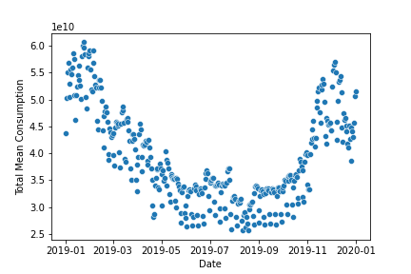
Daily consumption is plotted on the y axis (in Gigawatts), with the date on the axis. The graph is limited to year 2019.

This graph was created with scatterplot, well suited or this kind of data representation. No refinement of that graph was made, as it is intended as a basic first step in the data exploration visualisation.
It shows a higher consumption of electricity at the beginning and end of the year, during the coldest months. The differences between summer and winter months is up to a factor of 2.

- Chart #2
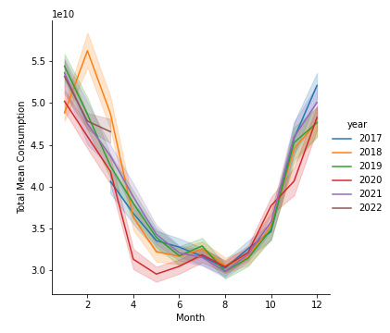
This second visualisation is the comparaison of the monthly electricity consumption year by year, using the full database.
This graph was created with relplot, using the 'line' kind and 'year' as hue to allow for comparing the consumption year on year. The color palette was changed to 'tab10', the basic palette wasn't differentiating enough between the lines.
No major change in electricity consumption level are observed year on year, except in early 2018 (strong cold snap) and in spring & automn 2020 (covid-19 lockdowns).

- Chart #3
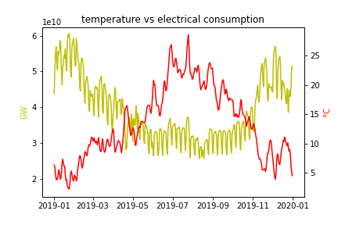
This third graph plotted the daily electricity consumption with the average temperature for the year 2019, with the timeline on the x-axis.
Matplotlib was used here, because of its ease to plot for 2 y-axis.
Legends on the y-axis were added for clarity, and colours set for contrast. The colours used aim at being close to the common representation of their attributes : yellow for electricity and red for temperature (blue could have been used as well).
The electricity y-axis was manually started at 1.5 GW, to optimise the space and the clarity of the graph.

As a logical follow-up of graph #1, the consumption has a neat inverse correlation with temperature level.

- Chart #4
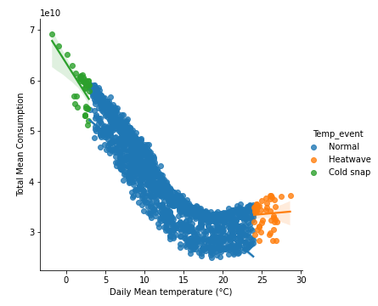
This lmplot intends to clearly show the correlation between average daily temperature and electricity consumption level, while highlighting the extreme temperature events.
Regression lines are shown, but I did not find any solutions to make them appear clearer. This is partially the result of the choice to use the whole 5-year database. Each dot represents one day, and this graphs thus contains over 1800 dots. This representation was kept as the relative concentration of dots around their trend naturally create its own regression line, albeit thicker.

Here the negative correlation between temperature and electrical consumption is more obvious with neatly oblique regression lines for cold snap and normal weather categories.
However the trends stops around 17-18°c, and then slightly reverse for warmer days.

- Chart #5
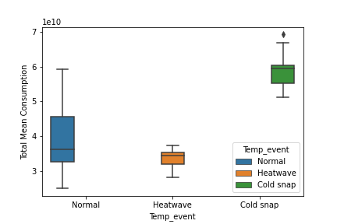
This last graph is using boxplot to study the concentration and variation of electricity consumption per weather categories defined earlier.
No parameter to the boxplot were changed from their standard values.
Extreme categories, cold snaps and heat wave, appear having a concentrated distribution, while the 'normal' weather is quite spreadout. Only the cold snap has one outlier value.
This pattern is mainly the result of much smaller datasets for the extreme categories, as these were arbitrarily defined.

Insights
- The first insight of these graphs is that the obvious pattern is confirmed. The electriticy consumption is highly correlated to the average temperature and the season. Indeed in France electricial heating is a widespread form of heating, coming on top of the need of light for darker winter days. The electricity consumption almost doubles between summer and winter.

- On the other end of the temperature scale, the electricity consumption also increased with heatwave, reflecting the use of air conditioning. However this impact scale is not as strong as the need of heating.

- Extreme events are also visible in these graphs: the 2018 cold snap which triggered record consumption, as well as the impact of 2020 covid-19 lockdowns. The latter especially lowered the consumption in spring 2020 driven by reduced economic activity.

- My data visualisation only scraps the surface of what drives the electricity consumption. One could bring the study further by separating weekday consumption from week-ends and bank holiday ones. The length of daylight variable could be included as well, to see if for a same temperature, the need of lighting impacts materially the overall level of electricity use. Adding more variables could lead to more and more precise machine learning scenarios, allowing for the estimation of future electricity use level based on weather forecast and period of the year using regressions.

- The dataset I picked for this project, along with the direction I chose for the graphs, is better suited to regression than classification. Electricity consumption level is the results of several inputs features, leading to a set of data containing continous variables. Once the significant and meaningful input are known and data is gathered on them, it is possible to build regression model forecasting the future consumption. Classification categories may be added, but I would see them as of secondary importance and would be built over the core continous data.

References
No external references were used for this project, except :
- Enerdis for the open data
- Stack Overflow, for clues on how to debug my Python program and get the results I wanted

